Name: Justin V Kalappura
Roll No: 10
Batch: MCA
Date: 09/05/2022

NETWORKING & SYSTEM ADMINISTRATION LAB

Experiment No.: 15

Aim:
Write a shell scripting program to check whether two numbers are greater,lesser or equal to each other.
Procedure:
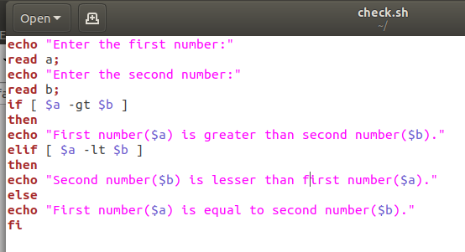

Output Screenshot:
